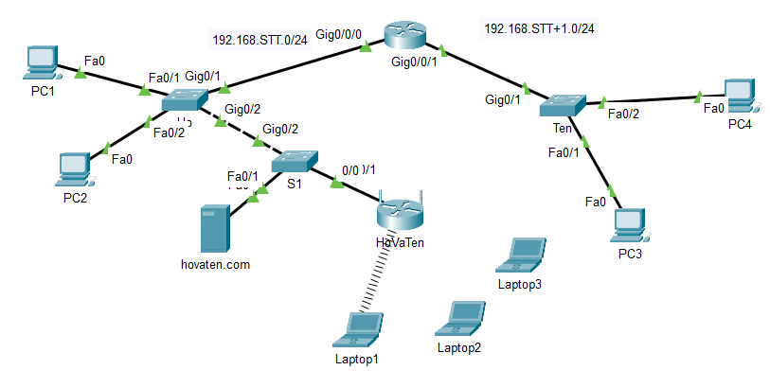

1. Create a diagram as shown above (wifi router and laptops will be done later)

2. Use the correct cable (straight cable, crossover cable)

3. Basic configuration on Switch FirstName, Switch LastName and Router MiddleName:

- User mode password is cisco, privileged mode password is tdmu, enable secret password is ittdmu, key code for all passwords

- Copy configuration from running-config into startup-config

- Set IP for the 2 interfaces of the router according to the network requirements in the picture.

4. Set IP for PC and Server HoVaTen.com

5. Check to make sure the PCs ping through and ping through the Server.

6. Add wifi router and configure: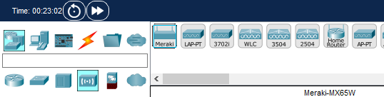

Setup:

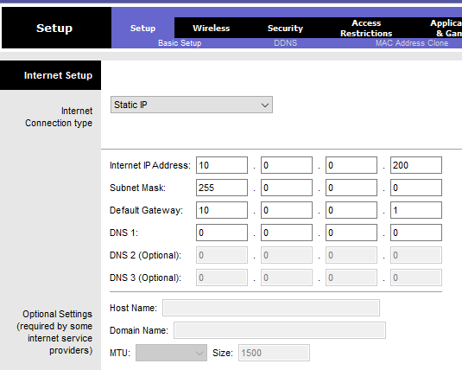

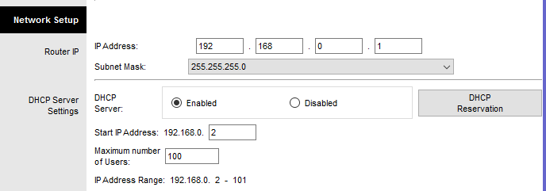

Wireless:

Basic wireless Settings:

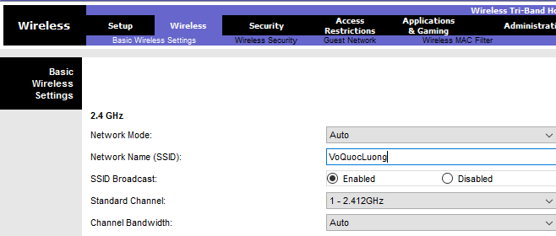

Wireless Security:

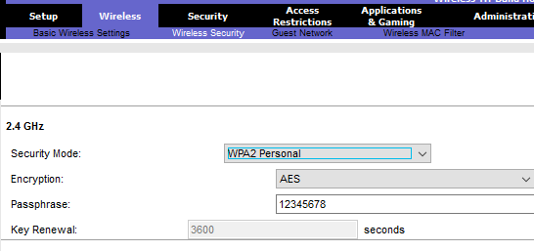

Tại laptop:

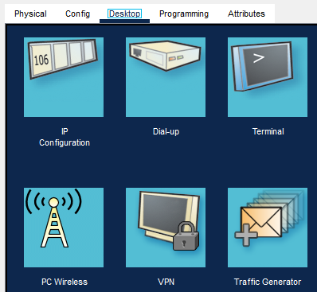

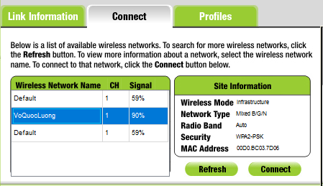

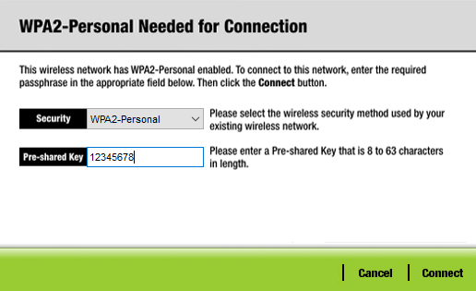

Result:

